**T02: Physical Layer**

**Q1:** Given the diagram below with 3 segments, what is the final output if the **input power is [1] watt**?

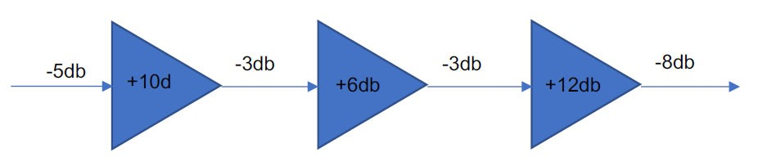

9dB

9=10log(P2/P1)

P2 = 1Watt

**Q2:** Sketch the differential Manchester and MLT-3 encoding for the bit stream: 1001111100010001, assuming the line is **initially in the low state**?

CNCO2000 – Tutorial 02



**Q3:** What is bandwidth? how is it different from speed, latency, and throughput?

**Bandwidth refers to maximum amount of data that can be transmitted over a network in a given amount of time. Speed refers to the rate at which data is transmitted over a network. Latency refers to the time delay between when the data is sent/received. Throughput refers to amount of data successfully transmitted over a network in a given amount of time. Throughput generally refers to efficiency of network due to a variety of factors mainly focusing on node to node connection.**

**Q4:** Name a few last mile technologies? What is the key significance of NBN?

**Dial-up, ISDN,**

**DSL, cable. NBN uses fibre optic. Theoretical speed is equivalent to the speed of light as it uses light waves to refract within a glass medium.**

**Q5:** What is the significance of using millimeter waves in 5G compared to the frequency band used in 4G? what is the disadvantage of using millimeter waves?

**Mm waves have a higher frequency and support a higher bandwidth, however cannot penetrate objects and so its effective speed is based on line of sight connection**

1. | P a g e